Segment Tree | Set 1 (Sum of given range)
Let us consider the following problem to understand Segment Trees.
We have an array arr[0 . . . n-1]. We should be able to
1 Find the sum of elements from index l to r where 0 <= l <= r <= n-1
2 Change value of a specified element of the array to a new value x. We need to do arr[i] = x where 0 <= i <= n-1.
A simple solution is to run a loop from l to r and calculate sum of elements in given range. To update a value, simply do arr[i] = x. The first operation takes O(n) time and second operation takes O(1) time.

Another solution is to create another array and store sum from start to i at the ith index in this array. Sum of a given range can now be calculated in O(1) time, but update operation takes O(n) time now. This works well if the number of query operations are large and very few updates.
What if the number of query and updates are equal? Can we perform both the operations in O(log n) time once given the array? We can use a Segment Tree to do both operations in O(Logn) time.
Representation of Segment trees
1. Leaf Nodes are the elements of the input array.
2. Each internal node represents some merging of the leaf nodes. The merging may be different for different problems. For this problem, merging is sum of leaves under a node.
An array representation of tree is used to represent Segment Trees. For each node at index i, the left child is at index 2*i+1, right child at 2*i+2 and the parent is at .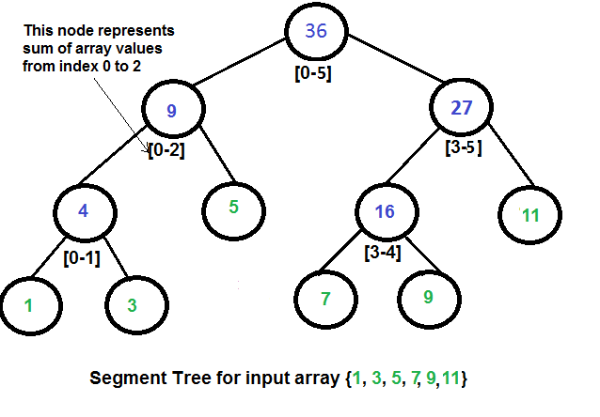
Construction of Segment Tree from given array
We start with a segment arr[0 . . . n-1]. and every time we divide the current segment into two halves(if it has not yet become a segment of length 1), and then call the same procedure on both halves, and for each such segment, we store the sum in the corresponding node.
All levels of the constructed segment tree will be completely filled except the last level. Also, the tree will be a Full Binary Tree because we always divide segments in two halves at every level. Since the constructed tree is always a full binary tree with n leaves, there will be n-1 internal nodes. So total number of nodes will be 2*n – 1.
Height of the segment tree will be . Since the tree is represented using array and relation between parent and child indexes must be maintained, size of memory allocated for segment tree will be .
Query for Sum of given range
Once the tree is constructed, how to get the sum using the constructed segment tree. Following is the algorithm to get the sum of elements.
int getSum(node, l, r) {
if the range of the node is within l and r
return value in the node
else if the range of the node is completely outside l and r
return 0
else
return getSum(node's left child, l, r) +
getSum(node's right child, l, r)
}

Update a value
Like tree construction and query operations, the update can also be done recursively. We are given an index which needs to be updated. Let diff be the value to be added. We start from root of the segment tree and add diff to all nodes which have given index in their range. If a node doesn’t have given index in its range, we don’t make any changes to that node.
Implementation:
Following is the implementation of segment tree. The program implements construction of segment tree for any given array. It also implements query and update operations.
// Java Program to show segment tree operations like construction,
// query and update
class SegmentTree {
int st[]; // The array that stores segment tree nodes

/* Constructor to construct segment tree from given array. This
constructor allocates memory for segment tree and calls
constructSTUtil() to fill the allocated memory */
SegmentTree(int arr[], int n) {
// Allocate memory for segment tree
//Height of segment tree
int x = (int) (Math.ceil(Math.log(n) / Math.log(2)));

//Maximum size of segment tree
int max_size = 2 * (int) Math.pow(2, x) - 1;

st = new int[max_size]; // Memory allocation

constructSTUtil(arr, 0, n - 1, 0);
}

// A utility function to get the middle index from corner indexes.
int getMid(int s, int e) {
return s + (e - s) / 2;
}

/* A recursive function to get the sum of values in given range
of the array. The following are parameters for this function.

st --> Pointer to segment tree
si --> Index of current node in the segment tree. Initially
0 is passed as root is always at index 0
ss & se --> Starting and ending indexes of the segment represented
by current node, i.e., st[si]
qs & qe --> Starting and ending indexes of query range */
int getSumUtil(int ss, int se, int qs, int qe, int si) {
// If segment of this node is a part of given range, then return
// the sum of the segment
if (qs <= ss && qe >= se)
return st[si];

// If segment of this node is outside the given range
if (se < qs || ss > qe)
return 0;

// If a part of this segment overlaps with the given range
int mid = getMid(ss, se);
return getSumUtil(ss, mid, qs, qe, 2 * si + 1) +
getSumUtil(mid + 1, se, qs, qe, 2 * si + 2);
}

/* A recursive function to update the nodes which have the given
index in their range. The following are parameters
st, si, ss and se are same as getSumUtil()
i --> index of the element to be updated. This index is in
input array.
diff --> Value to be added to all nodes which have i in range */
void updateValueUtil(int ss, int se, int i, int diff, int si) {
// Base Case: If the input index lies outside the range of
// this segment
if (i < ss || i > se)
return;

// If the input index is in range of this node, then update the
// value of the node and its children
st[si] = st[si] + diff;
if (se != ss) {
int mid = getMid(ss, se);
updateValueUtil(ss, mid, i, diff, 2 * si + 1);
updateValueUtil(mid + 1, se, i, diff, 2 * si + 2);
}
}

// The function to update a value in input array and segment tree.
// It uses updateValueUtil() to update the value in segment tree
void updateValue(int arr[], int n, int i, int new_val) {
// Check for erroneous input index
if (i < 0 || i > n - 1) {
System.out.println("Invalid Input");
return;
}

// Get the difference between new value and old value
int diff = new_val - arr[i];

// Update the value in array
arr[i] = new_val;

// Update the values of nodes in segment tree
updateValueUtil(0, n - 1, i, diff, 0);
}

// Return sum of elements in range from index qs (quey start) to
// qe (query end). It mainly uses getSumUtil()
int getSum(int n, int qs, int qe) {
// Check for erroneous input values
if (qs < 0 || qe > n - 1 || qs > qe) {
System.out.println("Invalid Input");
return -1;
}
return getSumUtil(0, n - 1, qs, qe, 0);
}

// A recursive function that constructs Segment Tree for array[ss..se].
// si is index of current node in segment tree st
int constructSTUtil(int arr[], int ss, int se, int si) {
// If there is one element in array, store it in current node of
// segment tree and return
if (ss == se) {
st[si] = arr[ss];
return arr[ss];
}

// If there are more than one elements, then recur for left and
// right subtrees and store the sum of values in this node
int mid = getMid(ss, se);
st[si] = constructSTUtil(arr, ss, mid, si * 2 + 1) +
constructSTUtil(arr, mid + 1, se, si * 2 + 2);
return st[si];
}

// Driver program to test above functions
public static void main(String args[]) {
int arr[] = {1, 3, 5, 7, 9, 11};
int n = arr.length;
SegmentTree tree = new SegmentTree(arr, n);

// Build segment tree from given array

// Print sum of values in array from index 1 to 3
System.out.println("Sum of values in given range = " +
tree.getSum(n, 1, 3));

// Update: set arr[1] = 10 and update corresponding segment
// tree nodes
tree.updateValue(arr, n, 1, 10);

// Find sum after the value is updated
System.out.println("Updated sum of values in given range = " +
tree.getSum(n, 1, 3));
}
}
//This code is contributed by Ankur Narain Verma

Output:
Sum of values in given range = 15
Updated sum of values in given range = 22
Time Complexity:
Time Complexity for tree construction is O(n). There are total 2n-1 nodes, and value of every node is calculated only once in tree construction.
Time complexity to query is O(Logn). To query a sum, we process at most four nodes at every level and number of levels is O(Logn).
The time complexity of update is also O(Logn). To update a leaf value, we process one node at every level and number of levels is O(Logn).

